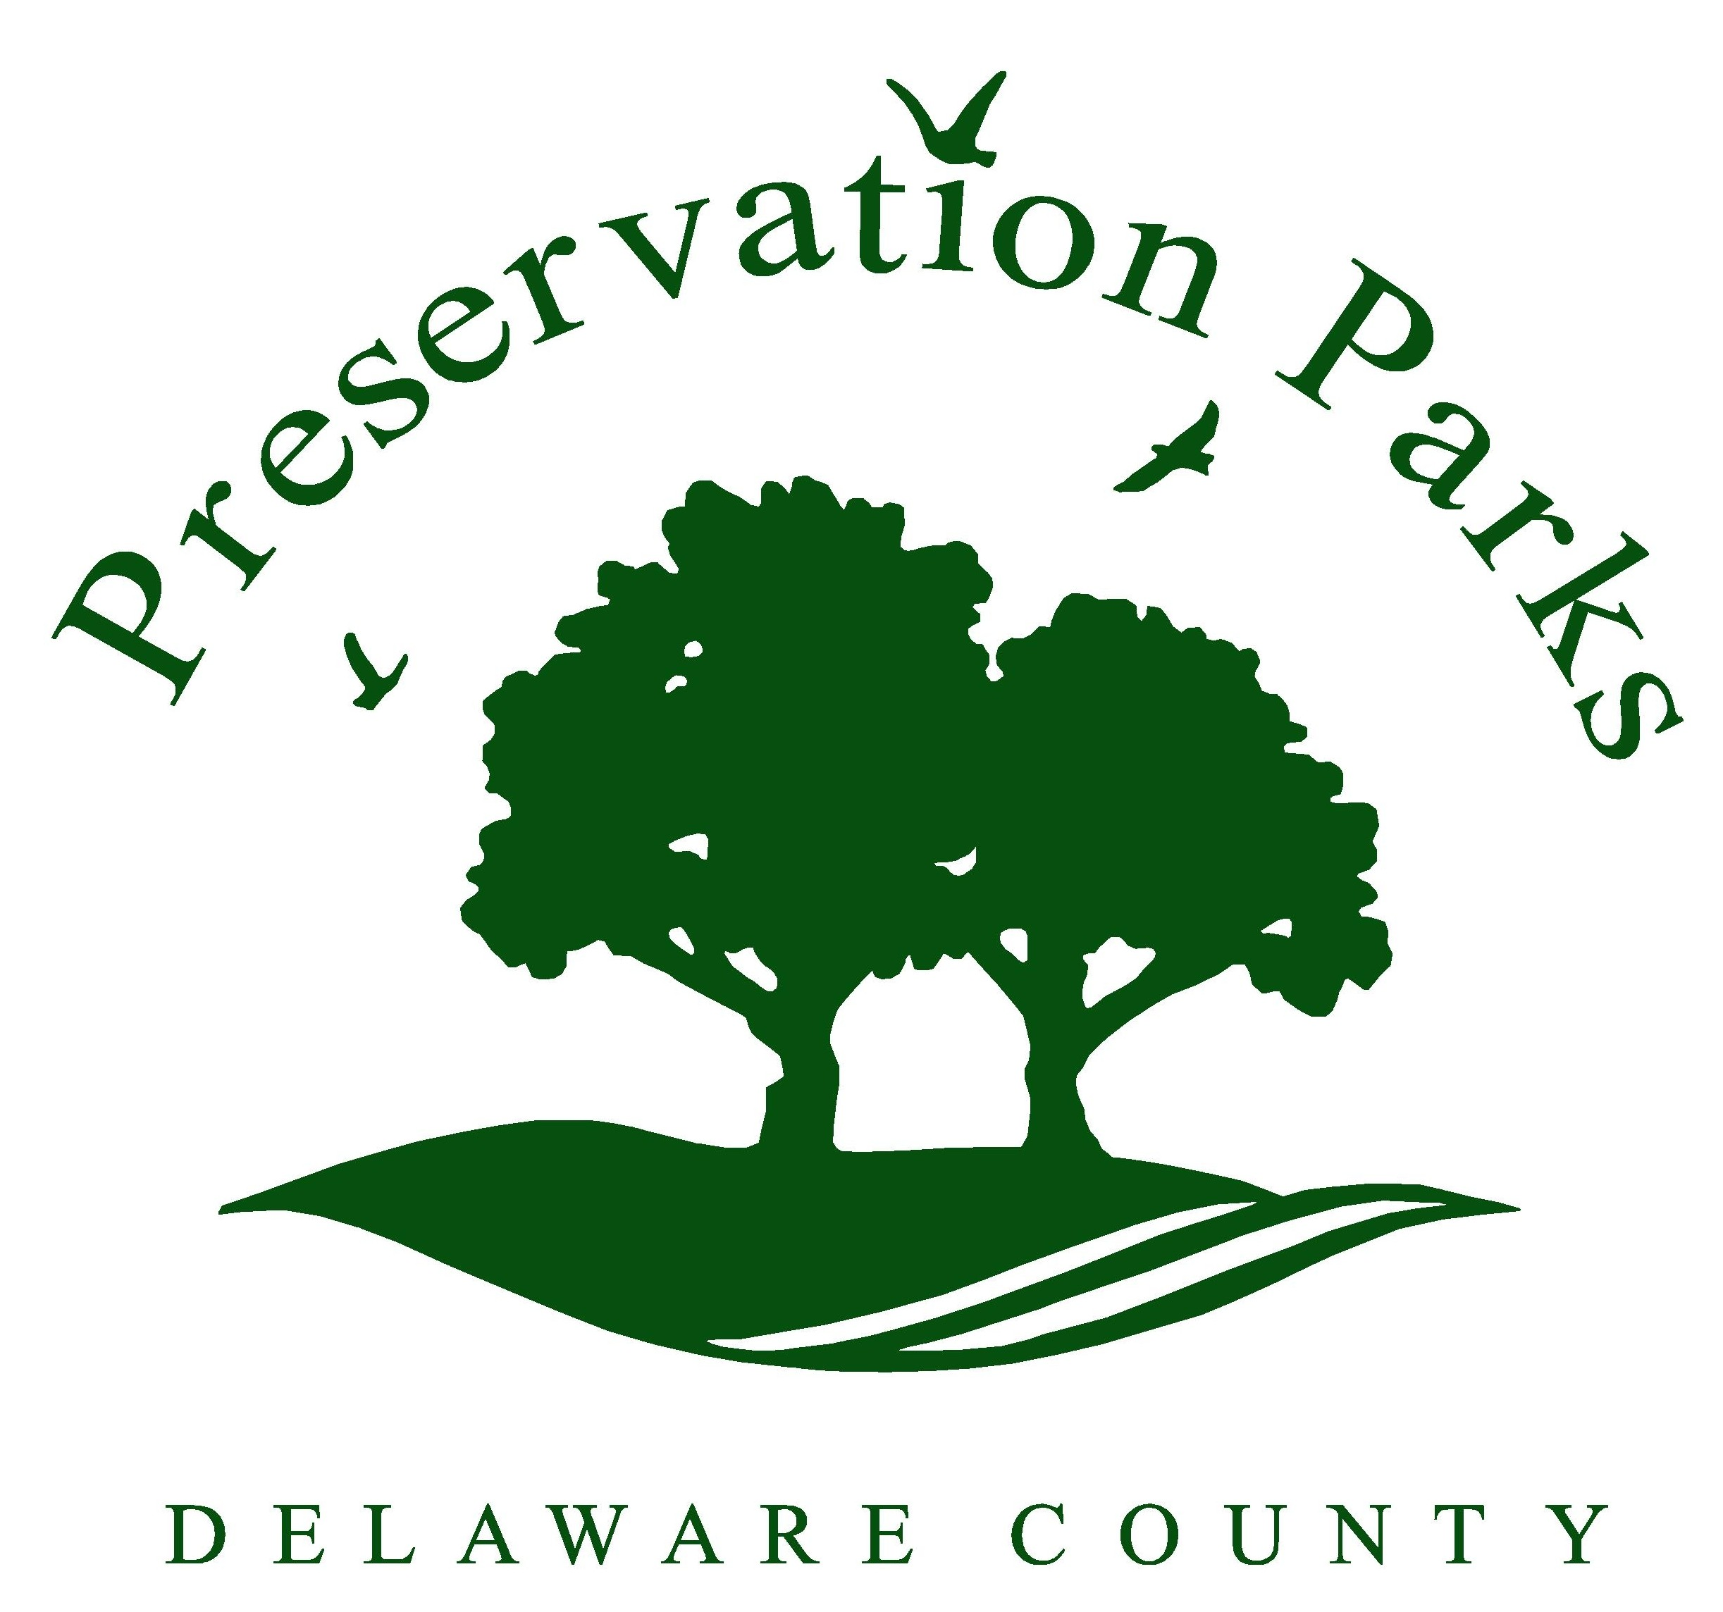  Preservation Parks of Delaware County  2656 Hogback Road  Sunbury, Ohio 43074  (740) 524-8600, ext. 6  www.preservationparks.com | Availability: Indoor meeting facilities are available Monday-Friday for business meetings only. Social events are not permitted in meeting rooms.  Corporate Fee Structure:  - $175 for four-hour block. The fee for additional time is $40 per hour.  - $75 deposit. Check is destroyed after rental, if facility is left clean.  Non-profit organizations, clubs, and schools:  - $80 for four-hour block. The fee for additional time is $20 per hour.  - $75 deposit. Check is destroyed after rental, if facility is left clean.

Group Permit for Indoor Meeting Facility
☐ Deer Haven Preserve Classroom (capacity 40)
☐ Shale Hollow Preserve Meeting Room (capacity 40-60)
40 classroom style (tables & chairs); 60 theater style (just chairs)
☐ Hogback Ridge Preserve Board Room (capacity 15)

Click here to enter text. | Click here to enter text.
Requested meeting date | Start time and End time (include set up & clean up)
Click here to enter text. | Click here to enter text.
Group Name  Click here to enter text. | Corporate group or non-profit?  Click here to enter text.
First name Last name | Number of people expected
Click here to enter text. | Click here to enter text.
Telephone number | Email address
Click here to enter text.
Mailing address, city, zip code
Click here to enter text.
Activities planned
Click here to enter text.
Please provide any other information we should know
Amenities requested
☐ Tables ☐ Projector/screen (Deer Haven only) ☐ Outdoor deck (Shale Hollow only)
☐ Chairs ☐ Kitchen access ☐ Other Click here to enter text.
*Renter responsible for set up and tear down

It is understood that the group using this permit will require only facilities within the park that are available to the general public, and, that all rules and regulations of Preservation Parks of Delaware County, attached hereto, apply to all persons, including the persons using this permit. No permit will be issued to a group of persons under the age of eighteen (18). Adult supervision of children’s groups is required at all times.

In case of cancellation of the reservation by the renting party, notification must be given to Preservation Parks by no less than 24 hours prior to the start of the reservation. Any cancellation received later than 24 hours in advance will forfeit the rental fee charged for the reservation. Cancellations can be made by contacting 740-524-8600, ext. 6, or saundras@preservationparks.com.

In consideration of the granting of this permit, the undersigned hereby accepts and agrees to the terms and conditions of the Park District and assumes responsibility for the good order of the above named group while it is in the park.

☐ I have read and agree to the Policies for Facility Reservations.

Click here to enter text. Click here to enter text.
Name  Please email completed form to saundras@preservationparks.com |  | Date

