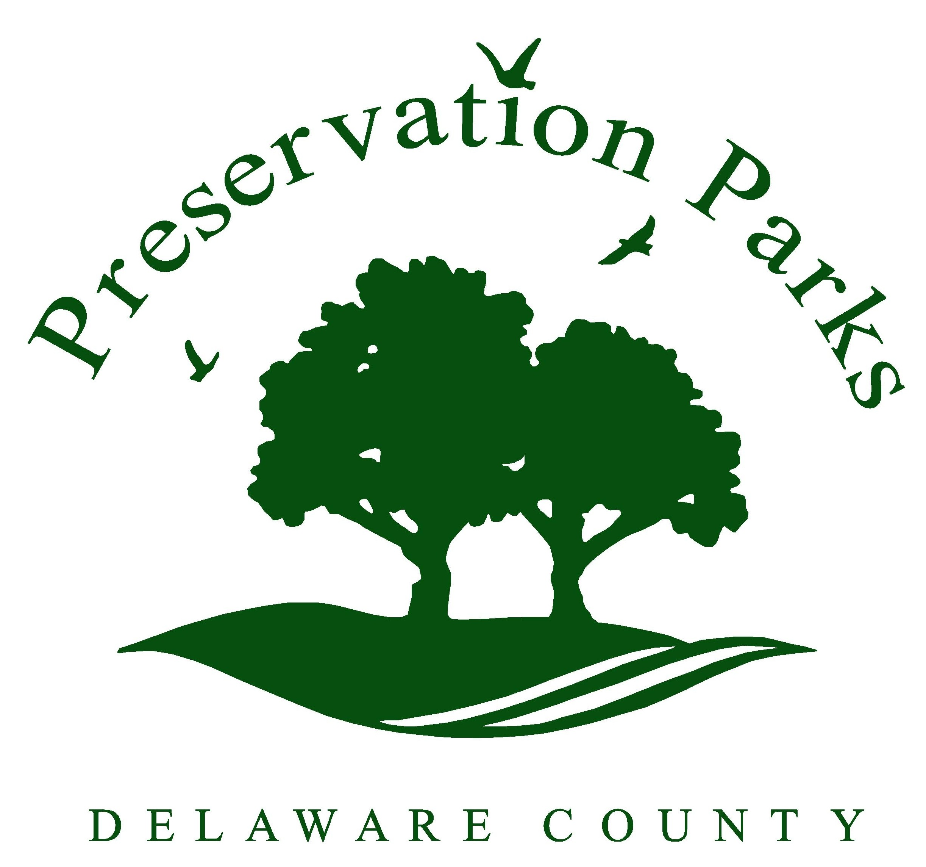  Preservation Parks of Delaware County  2656 Hogback Road  Sunbury, Ohio 43074  (740) 524-8600, ext. 6  www.preservationparks.com |  | Shelter Fee Structure:  - $60 for a four-hour block of time; four hours minimum. $20 each additional hour.  - $45 security deposit. Check is destroyed after reservation if shelter is left in clean condition.

Group Permit for Shelter Reservations
☐ Blues Creek Park (capacity 20, no electricity at this park)
☐ Emily Traphagen Park (capacity 30)
☐ Gallant Woods Park (capacity 60)
Parks offer restrooms, drinking fountain, charcoal grill, playground, picnic tables, and electricity unless otherwise indicated.
Click here to enter text. |  | Click here to enter text.
Date of event  Click here to enter text. |  | Park requested  Click here to enter text.
First and last name  Click here to enter text. |  | Start time & end time (include set up & clean up)  Click here to enter text.
Street address, City, ST, ZIP Code  Click here to enter text. |  | Number of people expected  Click here to enter text.
E-mail address  Click here to enter text. |  | Telephone number
Activities planned
Click here to enter text.
Please provide any other information we should know

Click here to enter text.
Name of Group
Amenities requested
☐ Horseshoes (at Emily Traphagen and Gallant Woods Park)
☐ Fire wood for the fireplace (at Emily Traphagen Park)

It is understood that the group using this permit will require only facilities within the park that are available to the general public, and, that all rules and regulations of Preservation Parks of Delaware County, attached hereto, apply to all persons, including the persons using this permit. No permit will be issued to a group of persons under the age of eighteen (18). Adult supervision of children’s groups is required at all times.

In case of cancellation of the reservation by the renting party, notification must be given to Preservation Parks by no less than 24 hours prior to the start of the reservation. Any cancellation received later than 24 hours in advance will forfeit the rental fee charged for the reservation. Cancellations can be made at 740-524-8600, ext. 6, or saundras@preservationparks.com.

In consideration of the granting of this permit, the undersigned hereby accepts and agrees to the terms and conditions of the Park District and assumes responsibility for the good order of the above named group while it is in the park.

☐ I have read and agree to the Policies for Facility Reservations.

Click here to enter text. Click here to enter text.
Name |  | Date
Please e-mail completed form to saundras@preservationparks.com

