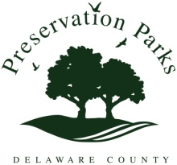

MINUTES

Preservation Parks of Delaware County
Friday, October 18, 2013 – 10:30 a.m. (Special Meeting)
Hogback Ridge Preserve
2656 Hogback Road, Sunbury 43074

Attendees: John Bader, Dan Boysel, Bruce Ruhl, Sue Hagan, Mary VanHaaften, Todd Younkin

The meeting was called to order by Chairman B. Ruhl at 10:31 a.m.

OLD BUSINESS
Update on Employment Search Services. D. Boysel moved to enter into a $6,000 contract with the Ohio Parks and Recreation Association (OPRA) that will allow the OPRA to conduct a search for an executive director for PPD. J. Bader seconded. J. Bader asked for clarification on a clause that specifies that OPRA will repeat the search at no additional cost, if the director chosen through the search leaves within one year. After a short discussion, the motion was approved, 3-0.

J. Bader moved that PPD Deputy Director G. Todd Younkin be authorized to sign the contract with OPRA in Executive Director Rita Au’s absence. Au is on vacation until Oct. 28. D. Boysel seconded. The motion was approved 3-0.

The meeting was adjourned at 10:37 a.m.

