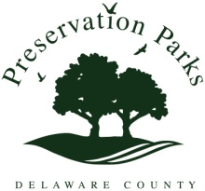

MINUTES – SPECIAL MEETING

Preservation Parks of Delaware County
Monday, February 10, 2014 10:30 a.m. (Special Meeting)
Double Eagle Club
6025 Cheshire Road, Galena OH 43021

Attendees: John Bader, Dan Boysel, Bruce Ruhl, Woody Woodward

The meeting was called to order by D. Boysel at 10:15 a.m.

EXECUTIVE SESSION: At 10:15 a.m., B. Ruhl moved that the board convene in executive session to consider the employment of a public employee. J. Bader seconded.
No action was taken.

B. Ruhl moved to adjourn the meeting at 3:55 p.m. J. Bader seconded. The motion carried.

